* React Portal provide the ability to breakdown to Dom Tree
* In simple word we can access the outside of the root things
* ReactDOM.createPortal accept two parameter,

1. First parameter is jsx or any react element
2. 2nd parameter on which div we have to show

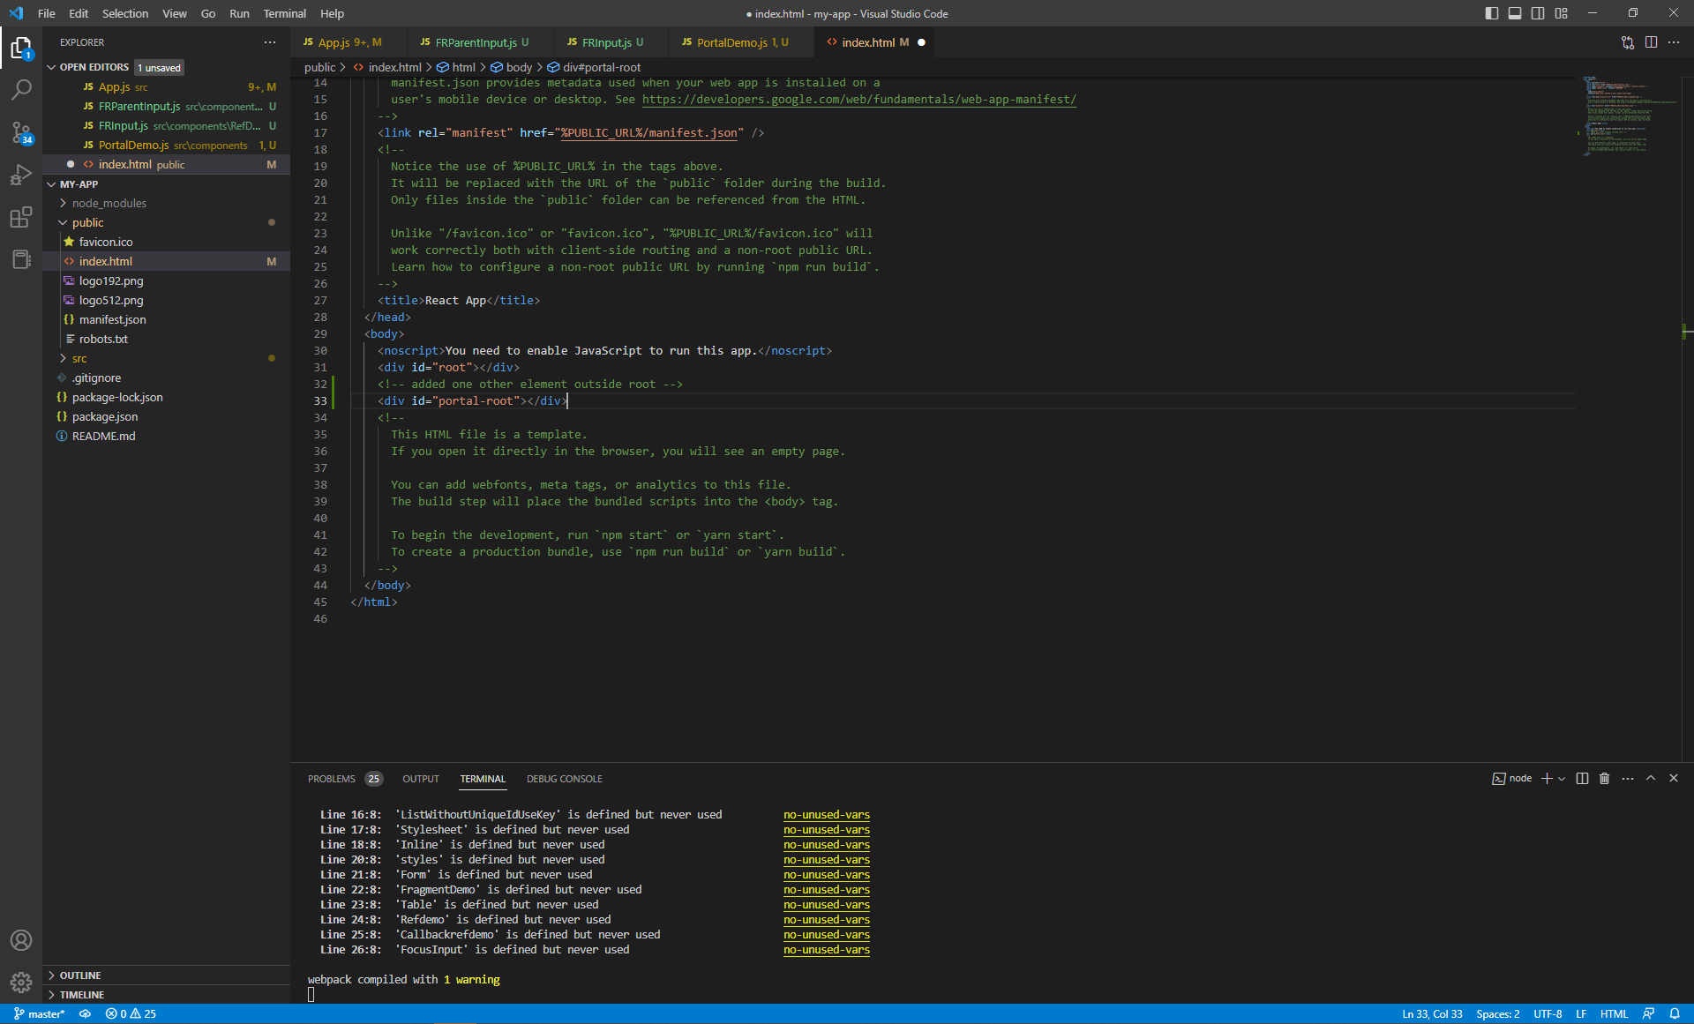

Create Component and attach to new element outside root like portal-root

import React from 'react'

//import React Dom package

import { ReactDOM } from 'react-dom'

function PortalDemo() {

    //Return ReactDom.createPortal => it accept two paramter first jsx and 2nd where we have to return and attach

  return ReactDOM.createPortal(

      <h1>

        Portal demo

      </h1>

    ,

    document.getElementById('portal-root')

  )

}

export default PortalDemo

